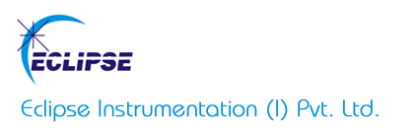

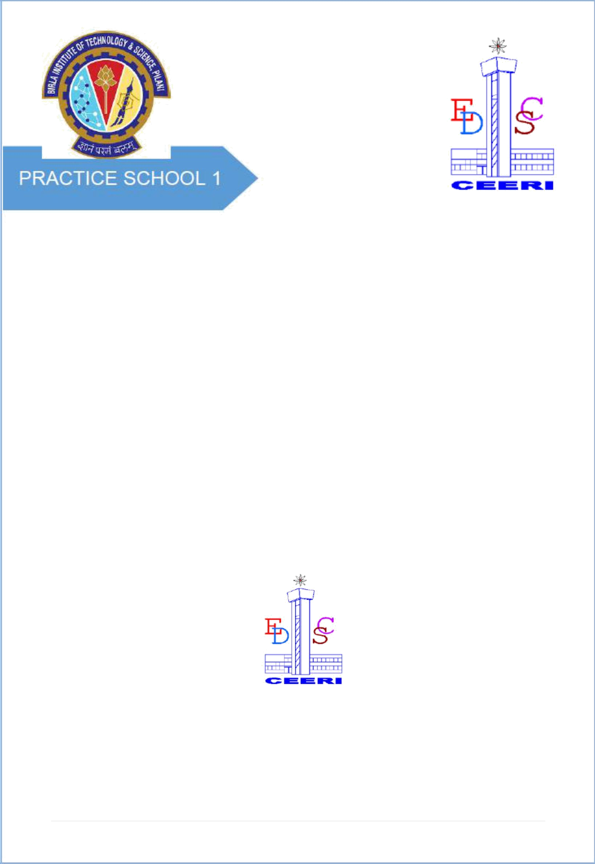

# PROJECT REPORT

**ON**

**WIRELESS VIDEO DATA TRANSMISSION**

**BY**

### PARTH AGGARWAL 2018A8PS0041G

**Prepared in partial fulfillment of the Practice School – I Course**

### at



**Eclipse Instrumentation Private Limited**

**A Practice School-I station of**

### BIRLA INSTITUTE OF TECHNOLOGY & SCIENCE, PILANI

**June, 2020**

**1 |** P a g e



**A REPORT ON**

**WIRELESS VIDEO DATA TRANSMISSION**

# BY

### Name of the ID.No. Discipline Student

**PARTH AGGARWAL 2018A8PS0041G Electronics & Instrumentation**

**Prepared in partial fulfillment of the Practice School-I Course**

**COURSE NO : BITS F221**

*AT*

### Eclipse Instrumentation Private Limited

A Practice School-I/II station of

### BIRLA INSTITUTE OF TECHNOLOGY & SCIENCE, PILANI

**June, 2020**

**ACKNOWLEDGEMENT**

I would like to thank everyone for providing me this opportunity, to learn and utilize my knowledge throughout the course of this project. I am extremely thankful to everyone for providing me their valuable insights, proper guidance and timely advice. I am sincerely grateful to them for helping me through any difficulties; I have been facing in this project.

I would also like to thank Priyal Nagare, Marketing Director of Eclipse Instrumentation Private Limited for motivating us and providing us this opportunity to work at this esteemed institute. I would also like to thank Dr.Noel Prashant Ratchagar, PS Coordinator and Pavan Kumar for their co-operation. I would also like to extend my heartfelt gratitude to Adityapratap Singh for providing me his valuable time and giving me this great opportunity of working under him on such an interesting topic.

I would especially like to thank Practice School Division for their constant support, maintaining discipline and helping us make the most of our time during PS-1.

### BIRLA INSTITUTE OF TECHNOLOGY AND SCIENCE PILANI (RAJASTHAN)

**Practice School Division**

**Station** ……… Eclipse Instrumentation Pvt. Ltd. ………. **Centre** ..................Thane… **Duration**....................6 weeks………………… **Date of Start**.........May 18, 2020……

**Date of Submission** ..................…………June 23, 2020……………………………………

**Title of the Project**: WIRELESS VIDEO DATA TRANSMISSION

### Name(s) Discipline(s)/of the student(s) ID No.

PARTH AGGARWAL Electrical and Instrumentation 2018A8PS0041G

### Name(s) and designation(s) of the expert(s):

Adityapratap Singh,Product development Engineer, Eclipse Instrumentation Private

Ltd.

**Name(s) of the PS Faculty:** DR. NOEL PRASHANT RATCHAGAR

**Key Words:** WiFi networks, LAN, Backlight Propagation,OT Lights, Hardware Modifications

**Project Areas:** Surgical Lighting

**Abstract:** As the technology progresses, wired systems are being replaced by wireless solutions to make installation's easier and cost effective, wireless video transmission is one of such technologies. We have to find a wireless video transmission device that can be used in operating theatre.The Device should be such that it takes a SDI input and gives SDI output or even better if we find a device that takes SDI input and gives HDMI output. Even the device should satisfy the following requirements low cost, compact size, low power consumption, low latency.

Signature of Student Signature of PS Faculty

Date: Date:

|  |  |  |  |  |
| --- | --- | --- | --- | --- |
|  | **TABLE OF CONTENTS** | |  | |
| 1. **Cover Page** | | **1** | |
| **2. Title Page** | | **2** | |
| ***3.* Acknowledgements** | | **3** | |
| **4.  Abstract** | | **4** | |
| **5. Introduction** | | **6** | |
| **6. Surgical Lights**   * **History** * **Need** | | **7** | |
| **7. Types of Surgical Lights** | | **9** | |
| **8. Lighting Methods** | | **10** | |
| **9. Imaging in Operational Theatre Lights** | | **11** | |
| **10. Principle of Wireless Data Transmission** | | **13** | |
| **11. Characteristics of Wireless Video Data Transmission 16**   * 1. **12 Advantages of Wireless Video Data Transmission 17**   2. **13. Wireless Broadcast Technologies 18**   3. **14. Wifibroadcast 21**   4. **15. Basic Camera Architecture 23**   5. **16. Technical Specifications 28**   6. **17. Different Wireless Video Transmission System Devices 32**   7. **18. Conclusion 34**   8. **19. Appendices**   9. **Appendix A: CAMERA SUPPORT FOR OPERATION THEATRE VIDEOGRAPHY 35**   10. **Appendix B: ORTHOGONAL FREQUENCY DIVISION MULTIPLEXING 37**   11. **Appendix C: TOWARD 5G CLOUD RADIO ACCESS NETWORK 39**   12. **20. References 41**   13. **21. Glossary 43** | | | | |

# INTRODUCTION

Surgical lights can be categorized based on the light type as either incandescent (conventional), LED lights and Halogen lights.

**INCANDESCENT**

These bulbs use at most 10 percent of the energy they consume to make visible light;the other 90 percent is wasted heat. They produce infrared and ultraviolet (UV) radiation.

**HALOGEN**

They contain a tungsten filament which extends the bulb’s lifespan and allows it to work at a much higher temperature than incandescent bulbs, which increases light output.

**LED**

LEDs run much cooler. They can last up to 50,000 hours—42 times longer than incandescent bulbs and 13 times longer than halogen bulbs.

This report’s primary objective is to elaborate on our project – **Wireless Video Data Transmission** and identifying the correct technology used in camera of Operation theatre surgical lights (OTL).

Wireless networking is a method by which homes, telecommunications networks and business installations avoid the costly process of introducing cables into a building, or

as a connection between various equipment locations, admin telecommunications

networks are generally implemented and administered using radio communication.

This implementation takes place at the physical level (layer) of the OSI model network structure.

Examples of wireless networks include cell phone networks, wireless local area networks (WLANs), wireless sensor networks, satellite communication networks, and terrestrial microwave networks.

Video has some fundamental differences in transmission requirements compared with traditional data traffic. During the early years of the Web, the conventional wisdom was that video streaming would have to be done over the User Datagram Protocol (UDP).

# 

**SURGICAL LIGHTS**

Surgical lights provide lighting in surgical suites and are designed to illuminate the surgical site for optimal visualization of small, low-contrast objects at varying depths in incisions and body cavities. A setup consists of a single- or multiple-lighthead assembly attached to a suspension arm.

**HISTORY**

**1. Before Electricity**

Before electricity they used sunlight as main medium for light needed in surgeries, they achieved it by making south east facing windows to get maximum illumination on the operation chair even after this light was easily blocked by hand of surgeon or any medical device so to alleviate the brightness and tackle these problems they further used mirrors to reflect more light to chair table but this only helped slightly while in order to reduce the heating effects of sunrays optical condensers were used.

**2. After Edison’s Bulb Invention**

By January 1879 Edison was able to build first high resistance electric bulb it worked on principle of heat and light produced when electric current is passed through a thin carbonized bamboo filament present in a vacuum chamber were vacuum helped in slowing filament melting process.

As they had electrically powered lights, those were fitted in floor stands and with time, ceiling mounted surgical lights were introduced to provide better lighting at different angles as surgeries were getting extensive and requirement was realized.

**3. After Halogen Bulb Invention**

A halogen bulb consists of a tungsten filament sealed inside of a glass chamber filled with inert or halogen gas such as iodine or bromine. These were used as surgical lights after Edison’s bulbs as they increased the luminance to 1, 00,000 lx on operation table.

**4. After Gas Discharge Lamps**

In 1990’s Gas discharge lamps were invented which generated light by sending an electric discharge through iodized gas called as plasma. These lamps used noble gases such as argon, neon, xenon or krypton or a combination of these gases. Some can include substances such as mercury, sodium and other metal halides which gets vaporized at startup to become a part of the gas mixture. In operation electrons of the gas atoms near the anode tend to leave atom due to electric field applied between two electrodes leaving positively ionized atoms. Electrons flow through the anode while the ions start moving towards cathode where they collide with other neutral gas atoms. After which ionized atoms snatch electron of neutral atom thus go into lower energy state producing photons. There is a delay after switching it on. Their color is dependent on the characteristic frequency of the atoms. They doubled the luminance compared to halogen bulbs that is 2, 00,000 lx but they instead increased eye fatigue and decreased surgeons’ efficiency.

**5. After LEDs Invention**

LED lamps has many times longer lifespan than equivalent incandescent lamps and are also way more efficient than most of fluorescent lamps, LED lamps require a electric driver circuit to work and this circuit also produces energy loss in heat hence reducing the efficiency of LED as a whole to 200 lumens per watt from 303 lumens per watt but still efficient than any other. Unlike fluorescent lamps they start immediately and frequent switch on and off doesn’t decrease its life expectancy though brightness decreases with lifetime of LED. They can also achieve different kinds of colors.

They run on direct currents and require lower voltage than any mains socket, so for converting alternating current to direct current they have a circuit containing rectifiers, capacitors, and other components. Many electric circuits may be simplified due to many led junctions arranged in series forming a led lamp of same voltage as of mains socket. LED’s nicer and cooler colors allow surgeons to have a good visibility they require during operations, they also eliminated problems with radiations that were linked with previous technologies. And can be ceiling, wall, ground mounted.

**NEED FOR SURGICAL LIGHTS**

**1. User Controlled Lighting**

The lighting for data collection as well as display (and viewing) is critical, yet complicated. In minimally invasive surgery, the lighting requirement is different because the surgeon is directing a probe inside the patient’s body while looking at a screen, which is difficult to read in bright light.

**2. Heat and Shadow Control**

Operating room lights are over the OR table to provide light without shadow and with the least amount of excessive heat. By combining proven reflector technology, the shadow control can be disciplined.

**3. Improved Visualization**

Surgical lights provide lighting in the OR and are specifically designed to "illuminate the surgical site for optimal visualization of small, low contrast objects at varying depths in incisions and body cavities."

**4. Enhancement of Deep Colors**

The hue should provide the ability to distinguish between different shades of red. (Tissues, veins, wounds)

**5. Deep Cavity Illumination**

No matter how deep or narrow a surgical site is, illumination or superior lighting will guide a surgeon. Overhead lighting does not go deep enough into the cavity. It can drift, create heat and shadows. Headlights bump each other and create shadows.

**TYPES OF SURGICAL LIGHTS**

Surgical lights can be categorized based on the light type as either incandescent (conventional), LED lights or Halogen lights.

**INCANDESCENT**

This well-known lighting type is the most dated and least efficient Heat radiates outward from the space heater as it does in an incandescent bulb, and only a small portion of the energy created is converted into usable light. They produce a considerable amount of infrared (IR) and ultraviolet (UV) radiation that can be damaging to fabrics and artwork over time. They’re designed to last around 1,200 hours.

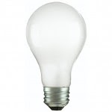 Figure 1 : Image of Incandescent Bulb

Source: <https://www.homedepot.com/p/Philips-50-Watt-A19-Dimmable-Incandescent-24-Volt-Light-Bulb-Soft-White-2650K-432561/202326769>

**HALOGEN**

They contain a tungsten filament. They produce a considerable amount of infrared (IR) and ultraviolet (UV) radiation. They last approximately 3,600 hours—three times longer than incandescent bulbs—but are not as efficient as compact fluorescent lamps (CFL) or LED bulbs.

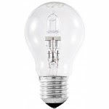 Figure 2: Image of Halogen Bulb

Source: <https://www.ylighting.com/43w-120v-a19-e26-clear-halogen-bulb-2-pack-by-bulbrite-uu518359.html>

**LED (Light Emitting Diode)**

LEDs run much cooler than incandescent and halogen bulbs, which greatly increases their longevity and enables them to function in cold temperatures. They can last up to 50,000 hours 42 times longer than incandescent bulbs and 13 times longer than halogen bulbs. They are available in many different whites and colors

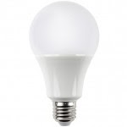 Figure 3: Image of LED Bulb

Source: <http://hajurbuy.com/product/led-bulb/>

**LIGHTING METHODS**

Quality lighting is critical for every operating room, and the method of light

varies depending on staff needs. Three of the most prevalent methods are:

**1. OVERHEAD/OPERATING LIGHTS**

They are usually either LED or incandescent. The lighting fixture can be mounted on a ceiling or wall and have handles that allow the surgeon to adjust the lighting as they see fit. It is also adjustable to help prevent glare.

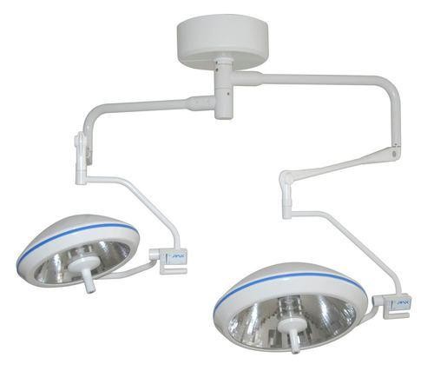

Figure 4: Image of Overhead/Operating Light

Source: <https://www.tradeindia.com/fp4040544/Overhead-Surgical-Lights.html>

**2. HEADLAMPS/ILLUMINATED LOUPES**

Headlamps can offer brightness, dependability and comfort for surgeons.

The lights are wearable and allow light to follow the attention of the surgeon.

Head lamps help create mobility for surgeon and shadow free illumination.

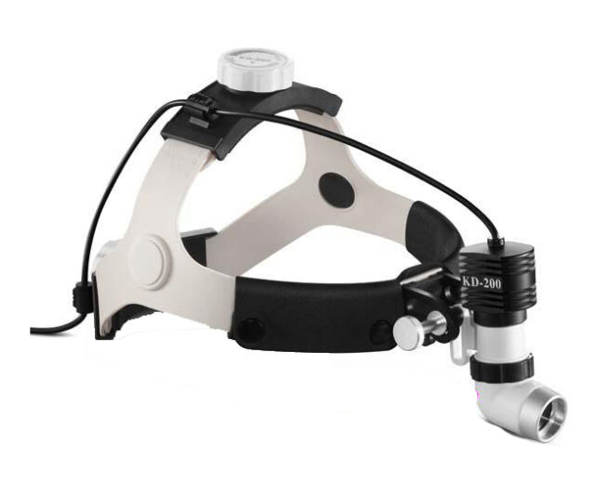 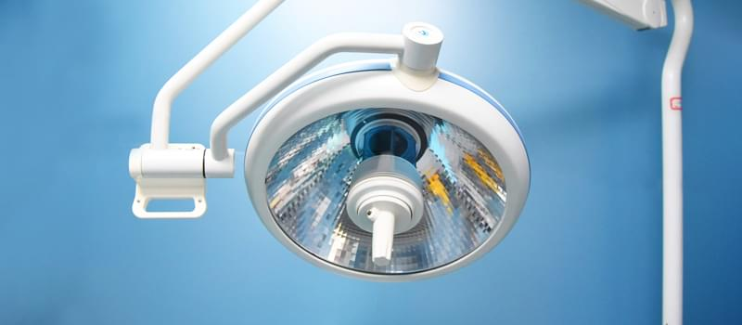

Figure 5: Images of Headlamps/illuminated loupes (left) and In-Cavity Light (Right)

Source: <https://www.ebay.com/itm/Headlamp-Magnifying-Glass-W-LED-Light-Illuminated-Head-Dental-Surgical-Loupe-/352715026501>

**3. IN-CAVITY LIGHTING**

In-cavity lighting allows for lighting deep inside surgical cavities. If current overhead and headlamp lighting are not adequate, in-cavity lighting is a viable

option. With this type of light, the light source is typically outside of the sterile field, meaning it can be a fixed light on its own or connected to a surgical retractor or instrument.

**IMAGING IN OPERATION THEATRE LIGHTS**

Many times, as per requirements OT Lights may have camera pre-installed, and some of the specification criteria required for selecting the camera are explained as follows:

**1. OPTICAL ZOOM:**

     Optical zoom is achieved by using a series of lens elements. Glass can move through the lens to zoom in or out. Optical zoom offers the best results and is the truest form of image magnification. Optical zoom offers lossless results. Optical zoom offers the best results and is the truest form of image magnification.

**2. DIGITAL ZOOM:**

      Digital zoom is like optical zoom, without mechanical work or glass elements. It will essentially cut off areas around your scene to make it seem like you are closer to the subject.

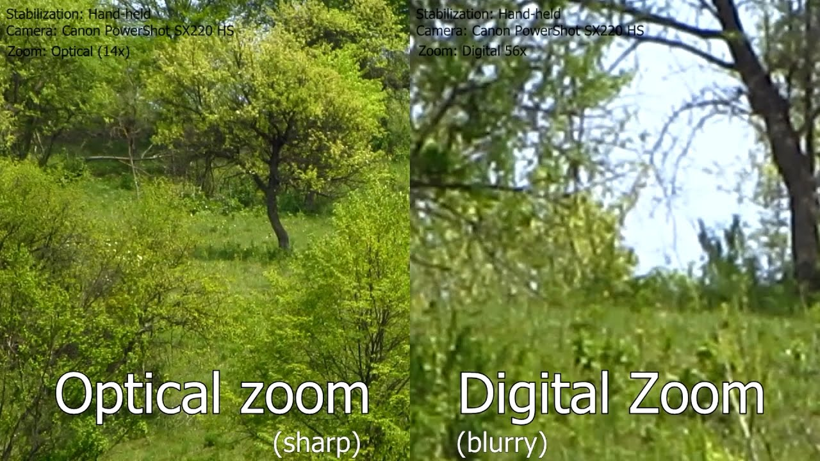

Figure 6: Images clicked using optical zoom (left) and digital zoom (right)

Source: <https://www.youtube.com/watch?v=_HlrN4DyZ5c>

**3. WHITE BALANCE**:

White balance (WB) is the process of removing unrealistic color casts, so that objects which appear white in person are rendered.Proper camera white balance must take into account the "color temperature" of a light source.

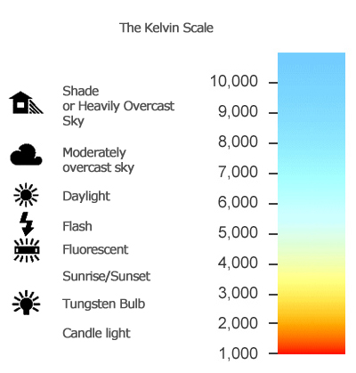 Figure 7: Depicts the temperature of different white lights

Source: <https://expertphotography.com/4-steps-to-understanding-white-balance/>

**4. SHUTTER SPEED:**

Shutter speed is the length of time camera shutter is open, exposing light onto the camera sensor. Shutter speed is responsible for two particular things: changing the brightness of your photo and creating dramatic effects by either freezing action or blurring motion.

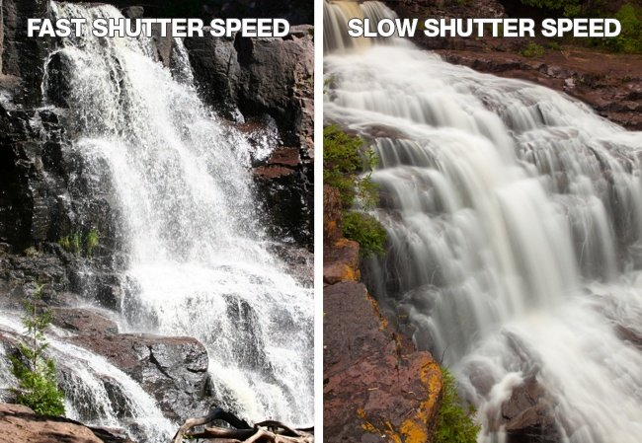

Figure 8: Images clicked by a camera at a fast (left) and slow (right) shutter speed

Source : <https://www.ideastogo.com/articles-on-innovation/innovation-as-a-camera-part-3>

**5. EXPOSURE:**

Exposure is the amount of light per unit area reaching a electronic image sensor, as determined by shutter speed, lens aperture, and scene luminance.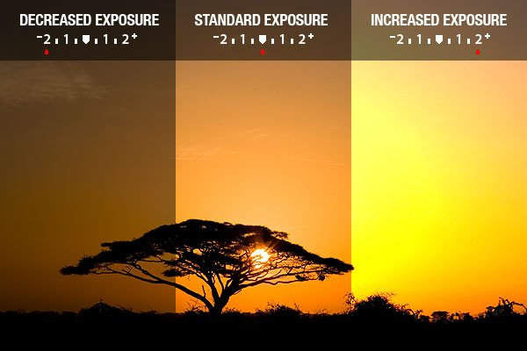

Figure 9: How the brightness changes as we move exposure from -2(left) to 0(middle) to 2(right)

Source : <https://www.exposureguide.com/exposure/>

**6. BACKLIGHT COMPENSATION:**

The Backlight Compensation [camera feature](https://docs.baslerweb.com/features.html) allows the camera to compensate for underexposed image regions. Backlight compensation tries to ignore small areas of high illumination so ensuring that the larger portion of the scene remain bright.

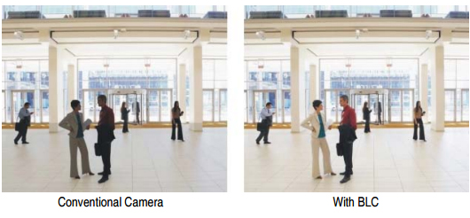

Figure 10: Showing the use of Backlight Compensation

Source:<https://www.unifore.net/ip-video-surveillance/network-camera-what-s-wdr-blc-hlc.html>

**PRINCIPLE OF WIRELESS DATA TRANSMISSION**

Wireless transmission is a form of unguided media. Wireless communication involves no physical link established between two or more devices, communicating wirelessly. Wireless signals are spread over in the air and are received and interpreted by appropriate antennas.

When an antenna is attached to electrical circuit of a computer or wireless device, it converts the digital data into wireless signals and spread all over within its frequency range. The receptor on the other end receives these signals and converts them back to digital data.

A little part of electromagnetic spectrum can be used for wireless transmission.

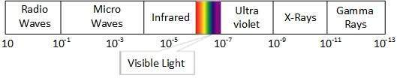

Figure 11**:** Electromagnetic Spectrum

Source**:** <https://www.tutorialspoint.com/data_communication_computer_network/images/electromagnetic_spectrum.jpg>

**RADIO TRANSMISSION**

Radio frequency is easier to generate and because of its large wavelength it can penetrate through walls and structures alike. Radio waves can have wavelength from 1 mm – 100,000 km and have frequency ranging from 3 Hz (Extremely Low Frequency) to 300 GHz (Extremely High Frequency). Radio frequencies are sub-divided into six bands.

Radio waves at lower frequencies can travel through walls whereas higher RF can travel in straight line and bounce back. The power of low frequency waves decreases sharply as they cover long distance. High frequency radio waves have more power.

Lower frequencies such as VLF, LF, MF bands can travel on the ground up to 1000 kilometres, over the earth’s surface.

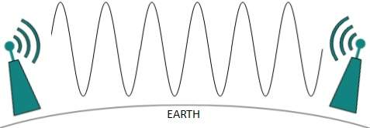

Figure 12**:** Radio Transmission

Source**:** <https://www.tutorialspoint.com/data_communication_computer_network/images/radio_wave_grounded.jpg>

Radio waves of high frequencies are prone to be absorbed by rain and other obstacles. They use Ionosphere of earth atmosphere. High frequency radio waves such as HF and VHF bands are spread upwards. When they reach Ionosphere, they are refracted back to the earth.

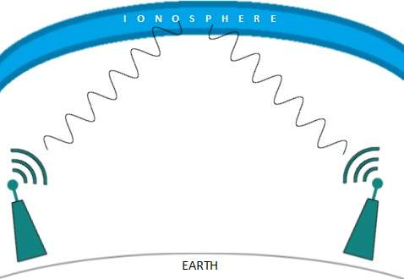

Figure13**:** High Frequency radio wave Transmission

Source**:** <https://www.tutorialspoint.com/data_communication_computer_network/images/radio_wave_ionosphere.jpg>

**MICROWAVE TRANSMISSION**

Electromagnetic waves above 100 MHz tend to travel in a straight line and signals over them can be sent by beaming those waves towards one particular station. Because Microwaves travels in straight lines, both sender and receiver must be aligned to be strictly in line-of-sight.

Microwaves can have wavelength ranging from 1 mm – 1 meter and frequency ranging from 300 MHz to 300 GHz.

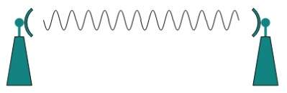

Figure 14**:** Microwave Transmission

Source**:** <https://www.tutorialspoint.com/data_communication_computer_network/images/microwave.jpg>

Microwave antennas concentrate the waves making a beam of it. As shown in picture above, multiple antennas can be aligned to reach farther. Microwaves have higher frequencies and do not penetrate wall like obstacles.

Microwave transmission depends highly upon the weather conditions and the frequency it is using.

**INFRARED TRANSMISSION**

Infrared wave lies in between visible light spectrum and microwaves. It has wavelength of 700-nm to 1-mm and frequency ranges from 300-GHz to 430-THz.

Infrared wave is used for very short-range communication purposes such as television and it’s remote. Infrared travels in a straight line hence it is directional by nature. Because of high frequency range, Infrared cannot cross wall-like obstacles.

**LIGHT TRANSMISSION**

Highest most electromagnetic spectrum which can be used for data transmission is light or optical signalling. This is achieved by means of LASER.

Because of frequency light uses, it tends to travel strictly in straight line. Hence the sender and receiver must be in the line-of-sight. Because laser transmission is unidirectional, at both ends of communication the laser and the photodetector need to be installed. Laser beam is generally 1mm wide hence it is a work of precision to align two far receptors each pointing to lasers source.

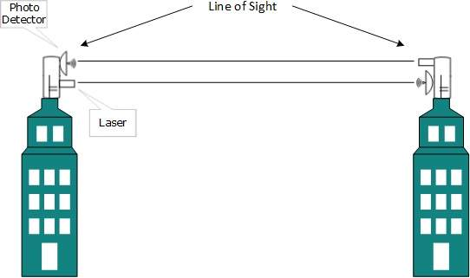

Figure 15**:** Light Transmission

Source**:** <https://www.tutorialspoint.com/data_communication_computer_network/images/light_transmission.jpg>

Laser works as Tx (transmitter) and photodetectors works as Rx (receiver).

**CHARACTERISTICS OF WIRELESS VIDEO DATA TRANSMISSION**

1. **Chunked delivery:** With modern streaming, video files are divided into short multi-second segments that are sent across the wire. Depending on the protocol, the segments can range from 2-10 seconds in length. By contrast, custom streaming protocols treat videos as monolithic blobs of information.
2. **HTTP communication:** Video segments are sent across the internet or corporate WAN using the standard HTTP protocol. Specifically, all modern streaming communications rely on TCP ports 80 (for unencrypted HTTP communication) and 443 (for SSL-encrypted communication).
3. **Stateless interaction:** When a client is watching a video, each request for subsequent video segments is independent of previous requests. In other words, there’s no persistent connection between client and origin server during video playback.
4. **Cache-friendly:** Chunked delivery is what enables video transmission to work in concert with HTTP caches that are ubiquitous on the internet, in content delivery networks (CDNs), and in many corporate networks. This has major benefits for network bandwidth management and WAN optimization—topics discussed in greater detail below.
5. **Adaptive-bitrate (ABR) playback:** Videos delivered using modern protocols are encoded at multiple quality levels. During playback, the client’s available bandwidth determines which quality level will provide the smoothest playback experience, and adjustments are made dynamically to minimize buffering while providing high-quality playback.
6. **Passive network architecture:** When video fragments are in transit on the network, intermediary nodes simply route the fragments toward their final destination, and in some cases, also cache the fragment. The intermediaries never execute any specialized code or modify the video fragments.
7. **Internet-intranet symmetry:** By default, modern protocols like HLS, DASH, Smooth, and HDS treat corporate WANs works no differently than the public internet. Both are passive, stateless networks comprised of hardware and software that can route video chunks to their final destination and cache video segments as needed.

**ADVANTAGES OF WIRELESS VIDEO DATA TRANSMISSION**

1. **Reduced management complexity**  
   Modern Streaming enables organizations to consolidate video network traffic to HTTP using TCP ports 80 and 443. In doing so, it eliminates the need to deploy and manage a separate caching infrastructure. In addition, modern streaming can improve manageability at the edge of the network by helping video content traverse firewalls. In most corporate networks, some level of protocol and port restriction is used to minimize attack surface area. While ports 80 and 443 are almost always open for the flow of generic web traffic, this luxury isn’t always extended to RTMP, RTSP, and other legacy protocols.
2. **Reduced costs**  
   Custom streaming protocols drive up infrastructure costs in two ways. First, they require organizations to invest in server hardware and software that form the backbone of the “video overlay” network. Second, their inefficiency in caching content can increase the amount of bandwidth required to stream popular video across the network. Modern streaming overcomes both of these challenges. Protocols like HLS leverage the existing HTTP server network, enabling organizations to save costs that would otherwise be spent on specialized hardware and software. And as the use of video increases, HTTP caching proxies dramatically reduce the bandwidth costs associated with uncached video.
3. **Improved scalability**  
   The ubiquity of HTTP servers, and the protocol’s native support for mirroring and edge caching, make HTTP the ideal choice for streaming large-scale live events and frequently accessed, on-demand content. When organizations invest in a modern protocol, scalability is an inherent benefit of the underlying network. By contrast, scalability with legacy protocols like RTMP is achieved only through additional investment in specialized hardware and software.
4. **Improved playback**  
   Modern streaming offers two benefits to the video playback experience. First, the use of HTTP and widely adopted codecs (e.g. H.264 for video and AAC for audio) helps ensure compatibility with a wide range of mobile devices. In addition, the use of adaptive bitrate streaming helps ensure that employees around the world get the best possible playback experience whether they’re at their desks on gigabit Ethernet or in the field consuming media over a 4G network.

**WIRELESS BROADCAST TECHNOLOGIES**

The three leading wireless broadcast link technologies are explained as follows:

1. **OFDM TECHNOLOGY**

In telecommunications, orthogonal frequency-division multiplexing (OFDM) is a

type of digital transmission and a method of encoding digital data on multiple carrier frequencies. OFDM has developed into a popular scheme for wideband digital communication, used in applications such as digital television and audio broadcasting, the transmitter is positioned on the camera; the receiver is located inside the OB-van or at the event’s media center where the content is gathered and transmitted forward.

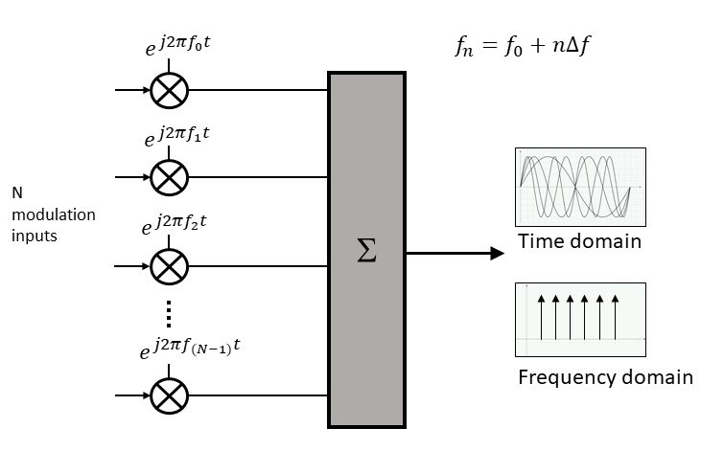

Figure 16: Encoding Digital Data on multiple carrier frequencies.

Source:<https://www.5gtechnologyworld.com/the-basics-of-5gs-modulation-ofdm/>

The cyclic prefix, which is transmitted during the guard interval, consists of the end of the OFDM symbol copied into the guard interval, and the guard interval is transmitted followed by the OFDM symbol. The reason that the guard interval consists of a copy of the end of the OFDM symbol is so that receiver will integrate over an integer number of sinusoid cycles for each of multipath when it performs OFDM demodulation with the FFT (Fast Fourier Transform).

OFDM is a method of encoding digital data on multiple carrier frequencies. OFDM / COFDM based wireless video link systems consist of transmitters and receivers. The transmitter is positioned on camera; the receiver is located inside the OB-van or at event’s media center where the content is gathered and transmitted forward.

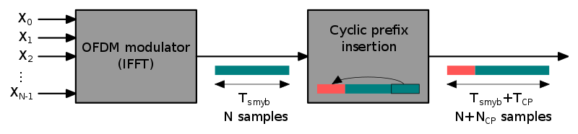

Figure 17: OFDM Cyclic Prefix Insertion

<https://en.wikipedia.org/wiki/Orthogonal_frequency-division_multiplexing>

A simple example as we see in figure: If one sends a million symbols per second using conventional single-carrier modulation over a wireless channel, then duration of each symbol would be one microsecond or less. If the same million symbols per second are spread among one thousand sub-channels, the duration of each symbol can be longer by a factor of a thousand (i.e., one millisecond) for orthogonality with approximately the same bandwidth. Assume that a guard interval of 1/8 of the symbol length is inserted between each symbol. Inter symbol interference can be avoided if the multipath time-spreading (the time between the reception of the first and the last echo) is shorter than the guard interval (i.e., 125 microseconds). This corresponds to a maximum difference of 37.5 kilometers between the lengths of paths.

1. **VIDEO LINKS OVER CELLULAR NETWORKS:**

In wireless video links over cellular networks, the transmitter is positioned on the camera or in a backpack carried by cameraman, transmitting the content over cellular network and from there to the broadcaster’s servers. The receiver is usually software on the server. Cellular systems often encounter congestion.

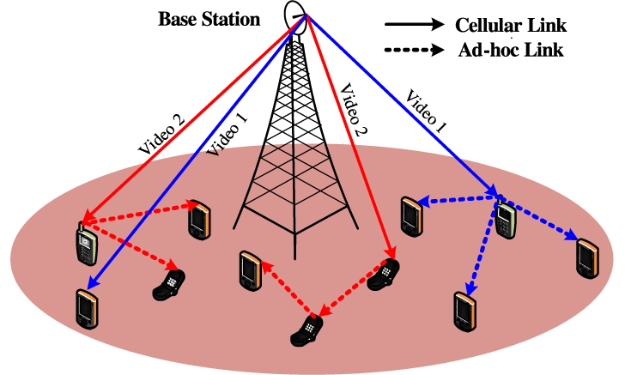

Figure 18: Video Dissemination over Hybrid Cellular and AdHoc Networks

Source:<https://www.computer.org/csdl/journal/tm/2014/02/ttm2014020274/13rRUEgs2tZ>

VoC (Video Over Cellular) is also rapidly gaining use in electronic news gathering and remote broadcasting, where it is used in place of remote pickup units (RPUs), which are temporarily fixed in a certain position, with an antenna often on telescoping pole or satellite dish atop an outside broadcast van. RPUs are also limiting in terms of setup time and space, safety regarding overhead powerlines, and the requirement for a line of sight back to the TV station or a remote receiving antenna.

VoC now allows reporters to transmit live from moving vehicles and is now frequently used for storm chasing and reporting live from the scene of other still-breaking news stories.. However, cellular service may be degraded or completely unavailable in the event of a mass call event or widespread power outage, both frequently caused by a disaster.

1. **VIDEO LINKS OVER WIFI**

In video over Wi-Fi systems. The transmitter is located on camera and the receiver is either near the Wi-Fi access point in the same location or at the TV station beyond

internet cloud. The main advantage of Wi-Fi video link solutions is their low cost,

making a perfect choice for low-budget productions.

Combining two solutions can overcome some of these inherent technological limitations. For example, when employing OFDM in a congested cellular environment OFDM link can be used to “jump” the first few hundred meters away from the cellular congestion. This solution enables the cellular transmitter to connect to clear cell far away from the event, avoiding congestion ad transmitting the broadcast live with minimal delay.

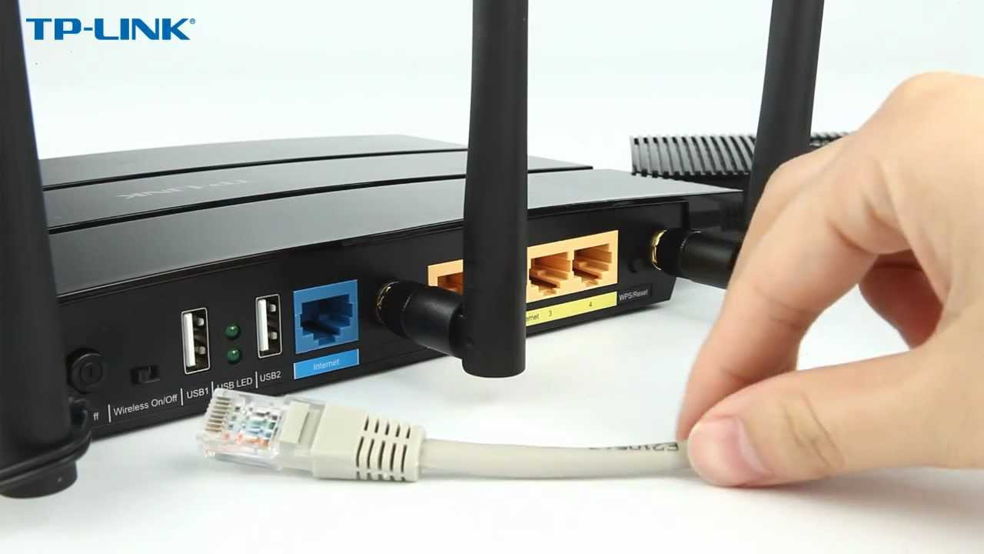

Figure19**:** A TP-Link Wi-Fi Router

Source**:** https://www.youtube.com/watch?v=k9zyKOI-AGs

**WIFIBROADCAST-ANALOG LIKE TRANSMISSION OF LIVE VIDEO DATA**

WIFI broadcast is a project aimed at the live transmission of HD video (and other) data using Wi-Fi radios. One prominent use case is to transmit camera images for first person view (FPV) of remote-controlled aircrafts.

In contrast to a normal WIFI connection WIFI broadcast tries to mimic the advantageous properties of analog link (like graceful signal degradation, unidirectional data flow, no association between devices).

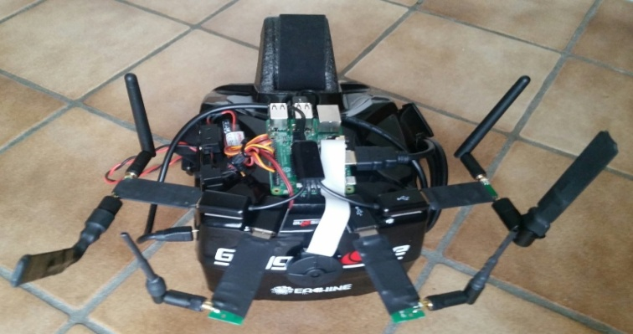

Figure 20**:** EZ Wi-Fi Broadcast

Source**:** <https://bit.ly/3hChGip>

WIFI broadcast puts the WIFI cards into monitor mode. This mode allows to send and receive arbitrary packets without association. Additionally, it is also possible to receive erroneous frames (where the checksum does not match). This way a true unidirectional connection is established which mimics the advantageous properties of an analog link.

A few of them are:

* The transmitter sends its data regardless of any associated receivers. Thus, there is no risk of sudden video stall due to the loss of association
* The receiver receives video as long as it is in range of the transmitter. If it gets slowly out of range video quality degrades but does not stall. Even if frames are erroneous, they will be displayed instead of being rejected.
* The traditional scheme “single broadcaster – multiple receivers” works out of the box. If bystanders want to watch the video stream with their devices they just have to “switch to the right channel”
* WIFI broadcast allows you to use several low-cost receivers in parallel and combine their data to increase probability of correct data reception. This so-called *software diversity* allows you to use identical receivers to improve reliability as well as complementary receivers (think of one receiver with an omnidirectional antenna covering 360° and several directional antennas for high distance all working in parallel).

dataflow

Figure 21**:** What Hardware is required

Source**:** <https://befinitiv.wordpress.com/wifibroadcast-analog-like-transmission-of-live-video-data/>

**WIFI CARD**

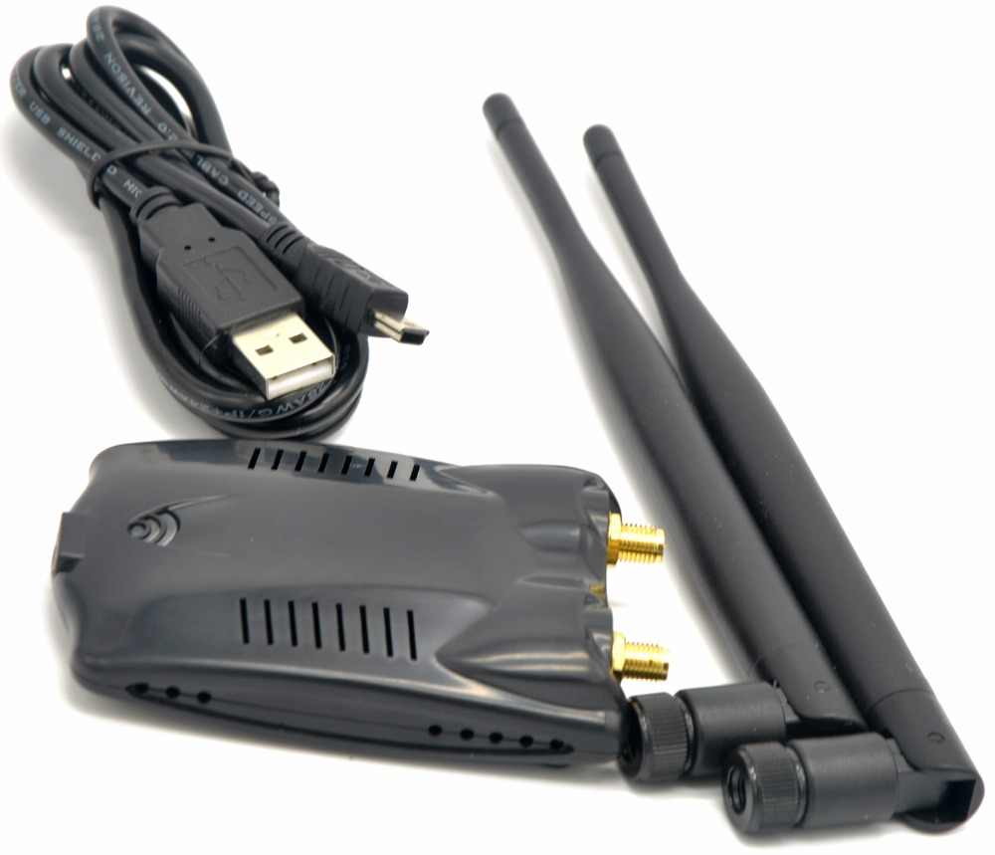Not all WIFI cards are compatible with WIFI broadcast. This is because WIFI broadcast uses injection mode which not fully supported by many WIFI chipsets. [**Tests**](https://befinitiv.wordpress.com/2015/02/22/finding-the-right-wifi-dongle-and-patching-its-kernel-driver-and-firmware/) have shown that the **ATHEROS AR9172** delivers good performance under WIFI broadcast for 2.4GHz.

For 5GHz operation Ralink RT5572 based devices are recommended since they work out of the box. The CSL-300 (with two antenna connectors!) and TP-LINK TL-WDN3200 are based on this chip.

Figure 22**:** ATHEROS AR9172

Source**:** <https://www.aliexpress.com/i/32836783576.html>

**BASIC CAMERA ARCHITECTURE IN OPERATION THEATRE LIGHT**

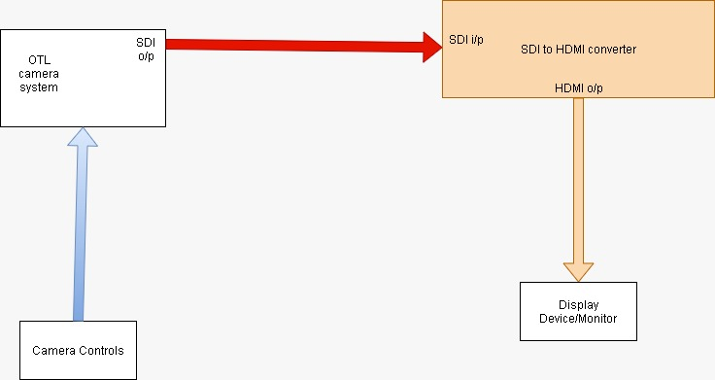

Figure 23**:** Basic Camera Structure

As displayed in the diagram above, camera output is in SDI format (Signal carried via Co-axial cables) , this is given to a SDI to HDMI converter kept at a place apart from OTL and it converts the SDI Input to an HDMI Output , as HDMI is supported by most of monitors .

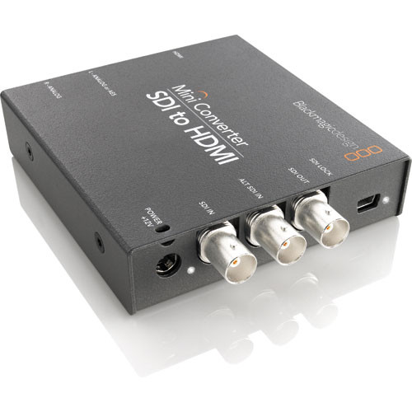

Figure 24**:** Blackmagic Design SDI to HDMI Mini Converter

Source**:** <shorturl.at/epvPS>

The **SDI to HDMI Mini Converter** from **Blackmagic** will accept SDI signal and convert it to an HDMI output. You can also choose to de-embed SDI audio to balanced AES/EBU or analog audio outputs. Use this device to connect SDI-based equipment to big-screen televisions, video projectors, and other HDMI displays.

However, if monitor supports SDI Input than this converter can be avoided, In between we have many different connectors and other components and we can save much on cost and space.

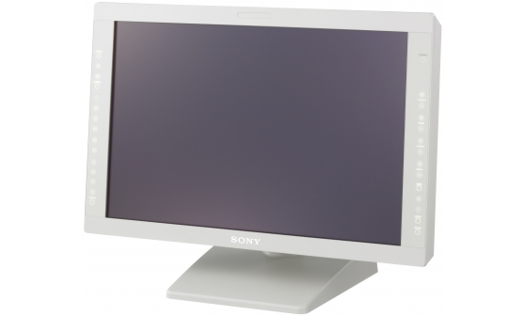

Figure 25**:** LMD-2451MD, 24-inch HD 2D LCD Medical Monitor

Source**:** <https://pro.sony/en_IN/products/surgical-monitors/lmd-2451md>

The LMD-2451MD has an advanced 24-inch LCD panel and has inherited conventional functions from the formerly introduced LMD-MD series. At full HD resolution WUXGA (1920x 1200) LMD-2451MD ensures very high-quality image representation. It accepts almost any SD and HD video signal in both analogue and digital, allowing doctors to view images simultaneously from multiple sources.

So our objective with the highest priority is to remove the interface with red color (in Figure 23), i.e. if a wireless transceiver takes a SDI Input and gives SDI Output it will be fine, but if we can even eliminate the orange section marked in the figure i.e if the transceiver takes SDI Input and gives HDMI output then it will be even better.

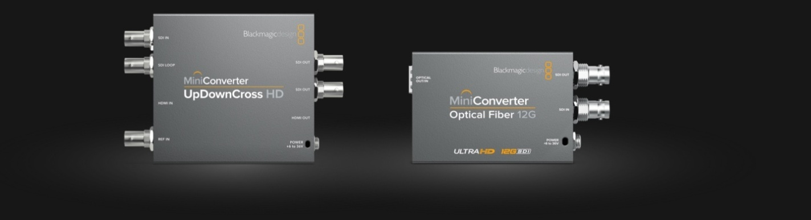

Figure 26**:** Mini Converter UpDownCross HD

Source**:** <https://www.blackmagicdesign.com/in/products/miniconverters>

Mini Converter UpDownCross HD is a full standards converter that lets you convert any SD or HD video format to any other SD or HD video format using high quality Teranex algorithms! Simply set the output format you need, and the input format is automatically converted, protecting your equipment from receiving an incorrect signal.

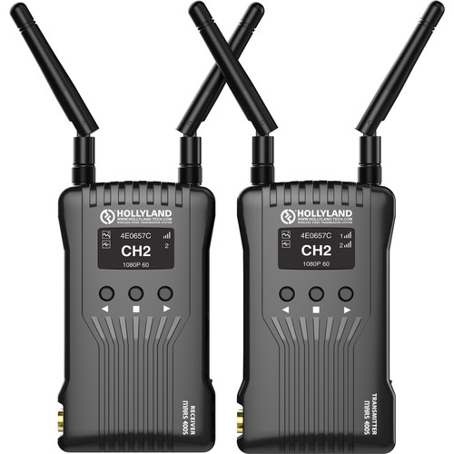

Figure 27**:** Hollyland Mars 400S SDI/HDMI Wireless Video Transmission System

Source**:** https://www.bhphotovideo.com/c/product/1507628- REG/hollyland_mars_400s_mars_400s_sdi_hdmi_wireless.html

The Mars400S from Hollyland is an entry-level 1080p60 transmitter/receiver system featuring a 400' line of sight transmission range. In a compact design, the transmitter and receiver each have an SDI and HDMI connection. The choice between the two connection types expands your compatibility options. Wi-Fi transmission to up to four mobile devices using IOS/Android HollyView app. It is built-in L-series battery plates.

As of now camera controls are also to extent through wired connections(marked in blue) ,so if it can be eliminated these as well it will be ideal, for this we can try to send commands over the same video transceiver interface or a different interface may also be used and be cost effective.

**MICROSCOPE CAMERA EP50**

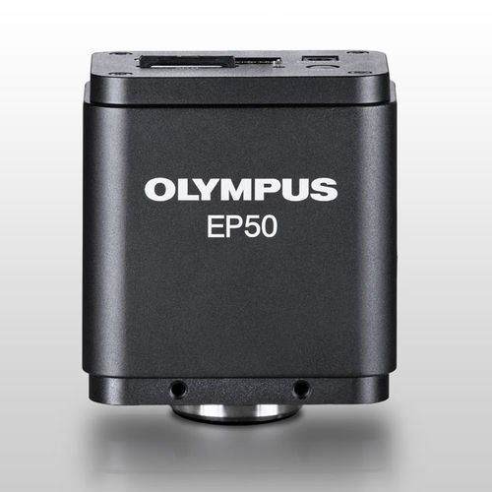

Figure 28**:** Microscope Camera / Digital / Wireless

<https://www.medicalexpo.com/prod/olympus-microscopy-europa/product-84543-897765.html>

It has flexible camera control and viewing options: connect using mobile devices or WLAN-enabled PCs/laptops via wireless or wired LAN connection. It has high-quality, crisp, 5-megapixel images. Fast frame rates enable students to navigate quickly through the specimen. It has Inspiring Enthusiasm, Interactive Learning and Interactive Learning.

It controls the EP50 camera using the EPview app for mobile devices or software for PCs/laptops. Up to 6 users can connect their devices to the same WLAN-enabled EP50 camera. We can access the images of other EP50 cameras in the classroom.

So, while selecting any device, our main motives should include:

* Low Cost
* Compact Size
* Low Power Consumption
* Low Latency

Medical devices can be divided into two categories: those that use an internal non-rechargeable battery (e.g., pacemakers) and those that couple power inductively (e.g., cochlear implants). The former heavily duty-cycle the operation of systems to conserve power. The transceiver is off most of the time. Therefore, the off-state current and the current required to periodically look for a communicating device must be extremely low (<1 uA). In both cases, low power (<6 mA) is also required for both transmit and receive.

**OLED TECHNOLOGY**

OLED (Organic Light Emitting Diodes) is a flat light emitting technology, made by placing a series of organic thin films between two conductors.OLEDs are emissive displays that do not require a backlight and so are thinner and more efficient than LCD displays (which do require a white backlight).

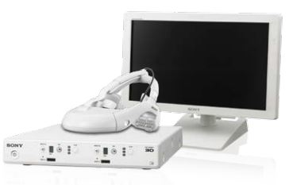

Figure 29**:** PVM-2551MD Medical OLED Monitor

Source: <https://www.imotek.com/downloads/products/product165_1.pdf>

Sony innovative OLED technology delivers deep black, high-contrast, accurate color reproduction and quick response times with virtually no motion blur.

**HMS-3000MT Head Mounted Display**

The Sony Head Mounted Display uses OLED panels for detailed image representation of the viewed area. Two 18mm (diagonal) panels positioned inside the monitor, one in front of each eye. Independent HD images are displayed on the left and right panels respectively with no crosstalk.

**VIRTUALLY NO MOTION BLUR**

The OLED electroluminescent layer responds almost instantly to changes in electrical current input, achieving superb response performance for blur-free reproduction of fast-moving images. This is beneficial for a variety of critical medical applications, such as rigid endoscopic surgery and flexible endoscope investigation.

**REPRODUCES SMALL DIFFERENCES IN COLOUR**

OLED exceeds the color range of any previous Sony monitor technology. The advanced micro-cavity structure uses an optical resonance effect in combination with accurate color filters to calibrate and stabilize RGB color accuracy. This combination is also effective in reducing ambient light reflection. Consequently deep color reproduction can be achieved with virtually no degradation, particularly in bright environments.

**DISPLAY**

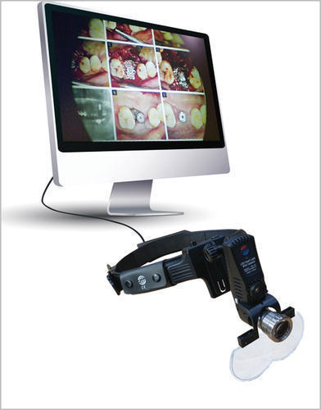

Figure 30**:** A HDR workflow Display

Source: <https://www.indiamart.com/proddetail/led-surgical-head-light-with-camera-and-recorder-from-lumens-medical-20188638573.html>

Now both professionals and students can benefit from a clearer picture of surgical procedures with displays that can assist with more accurate differentiation of colors and tissue types.

**TECHNICAL SPECIFICATIONS**

1. **RESOLUTION**

A digital image is a rectangle made up of many small squares of colour called pixels. The number of pixels across the width and height of the image is called the resolution. An image with 640 pixels across the width and 480 pixels high has a resolution of 640x480. The more pixels in the image file, the higher the resolution. Many cameras offer a choice of resolutions from 640x480 up to 5000x3500 or higher.

Consider a circle that is being displayed on a screen so if we had less number of dots i.e. lower resolution than we would have these zig zag borders as in 1st circle while if we had a better resolution than image would have smoother edges and give a sharper look (Right circle) so in lay man terms higher the resolution sharper an image looks.

Figure 31**:** A circle in different resolutions

Source**:** <https://developer.apple.com/design/human-interface-guidelines/ios/images/ImageResolution-Graphic.png>

1. **FRAME RATE**

A frame rate is simply the frequency at which independent still images appear on the screen. The human eye can see as much as 10 or 12 images per second and process them separately, while 16fps is already perceived as a movement. However, in videos with lower frame rates movements appears jerky, while the characters move at unnatural speeds.

where changing these stationary images is perceived like a car is moving so if we had higher fps, then we can see more motion details as in the upper most where we had 12 fps film we can see more instances of car moving in between two frames of lowermost case.

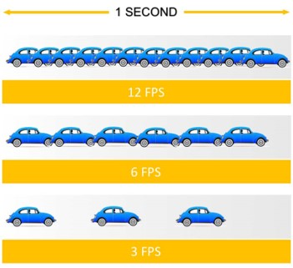

Figure32**:** Different fps compared with timeline.

Source**:** <https://support.flipaclip.com/s/attachments/8878/3/13/789cefc74aafa479a36e02476c45040d.png>

1. **LATENCY**

In terms of video streaming, end-to-end latency is the total delay, or total time elapsed between when a frame is captured on a transmitting device and the exact instant when it is displayed on the receiving device. Latency is typically expressed in terms of time, most commonly in milliseconds or seconds.

**What is “Zero Latency”?**

By definition, zero latency means there is no delay whatsoever between the video on your device and the one being broadcast to your television—even if that transmission is occurring from 100 feet away, through walls, ceilings, and floors.

.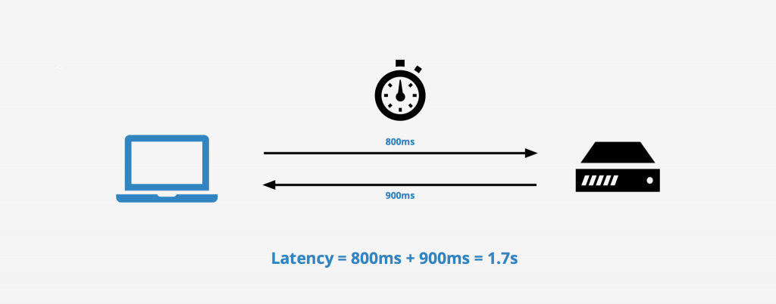

Figure 33**:** Network Latency

Source**:** <https://networkencyclopedia.com/wp-content/uploads/2019/10/latency-1024x402.png>

1. **COLOUR SPACE**

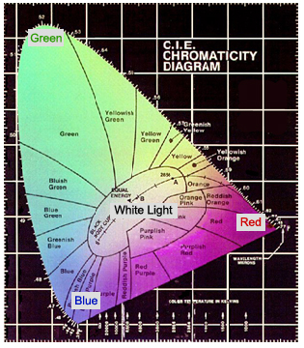Figure 34**:** Chromaticity Diagram

Source**:** Http://www.arcsoft.com/images/topics/darkroom/what-is-color-space-overview.jpg

A range of colours can be created by the primary colours of pigment and these colours then define a specific colour space. **Colour space**, also known as the colour model (or colour system), is an abstract mathematical model which simply describes the range of colours as tuples of numbers, typically as 3 or 4 values or colour components (e.g. **RGB**).

A colour space is a useful method for users to understand the colour capabilities of a particular digital device or file. It represents what a camera can see, a monitor can display, or a printer can print, and etc. There are a variety of colour spaces, such as RGB, CMY, HSV, HIS.

1. **RANGE**

Range it is the maximum distance we can go with our wireless devices connected and working, but the range advertised in most of the devices is when there is no blocking of sight between transmitter and receiver.

1. **HDMI AND SDI PORTS**

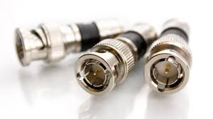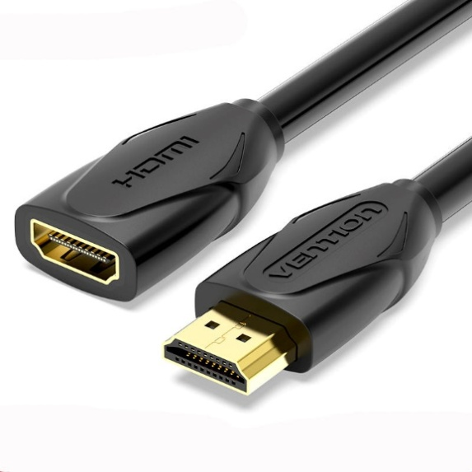

Figure 35**:** SDI Port(left) and HDMI (right)

Source**:** <https://newsandviews.dataton.com/hubfs/Blog%20BNC%20SDI.jpg> ;

<https://imgaz1.staticbg.com/thumb/large/oaupload/ser1/banggood/images/F1/32/f7369371-ced2-40b3-84e3-12fe818aad64.jpg.webp>

.

**What Is HDMI?**

HDMI is a video standard commonly used in consumer / prosumer environments. HDMI sends uncompressed video and embedded audio signals to any device that can display or encode video.

**Common HDMI Connector Types**

-Standard HDMI

-Mini HDMI (DSLR + mini camcorders)

-Micro HDMI (GoPros + action cams)

**What Is SDI?**

SDI is a professional video signal that is preferred in production environments because of its longer range (up to 300 feet) and reliability,

1. **FREQUENCY**

Wireless signals occupy a spectrum, or wide range, of frequencies: the rate at which a signal vibrates. If the signal vibrates very slowly, it has a low frequency. If the signal vibrates very quickly, it has a high frequency. Frequency is measured in Hertz, which is the count of how quickly a signal changes every second. As an example, FM radio signals vibrate around 100 million times every second! Since communications signals are often very high in frequency, we abbreviate the measurements for the frequencies - millions of vibrations a second is Megahertz (MHz), and billions of vibrations a second is Gigahertz (GHz). One thousand Megahertz is one Gigahertz.

Example Frequency Ranges

Below we can see the span of frequencies that are commonly used in communications. Broadcast transmitters for AM, FM and Television use frequencies below 1000 MHz, Wi-Fi uses two bands at higher frequencies - 2.4 and 5GHz. Cellular phones use many different frequencies.

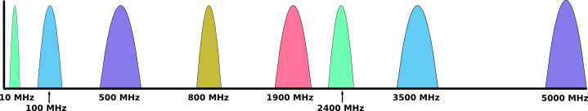

1. The frequencies from left to right:

2. AM Radio: Around 10MHz

3. FM Radio: Around 100MHz

4. Television: Many frequencies from 470MHz to 800MHz, and others.

5. Cellular phones: 850MHz, 1900MHz, and others

6. Wi-Fi: 2.4GHz

7. Satellite: 3.5GHz

8. Wi-Fi: 5GHz

1. **CHANNELS**

Radio frequency (RF) channels are an important part of wireless communication. It is recommended that nonoverlapping channels be used for communication. In the U.S., 802.11b/g use 11 channels for data communication, as mentioned; three of these—channels 1, 6, and 11—are non overlapping. When troubleshooting a wireless network, be aware that overlapping channels can disrupt the wireless communications.

**DIFFERENT WIRELESS VIDEO TRANSMISSION SYSTEMS DEVICES**

1. **TERADEK BOLT 500 XT**

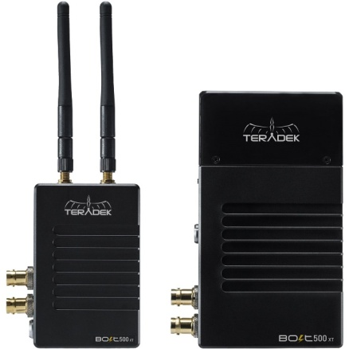

**Source:** <https://static.bhphoto.com/images/images500x500/1524585083_1403845.jpg>

* Up to 1080p
* Backward compatible with select systems
* 3G-SDI and HDMI Inputs/Outputs
* Cross Conversion
* 5Ghz Channels
* $1,499.00

1. **TERADEK VIDIU GO**

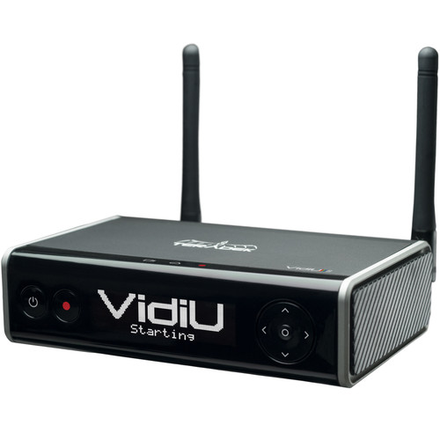

**Source:** https://www.bhphotovideo.com/images/images2000x2000/teradek_10_0229_vidiu_go_1401708.jpg

Up to 1080p60

Inputs: SDI and HDMI

2 x USB Ports, Ethernet, and Wi-Fi

Compression: AVC/H.264 and HEVC/H.265

$1,490.00

1. **ACCSOON CINEEYE AIR**

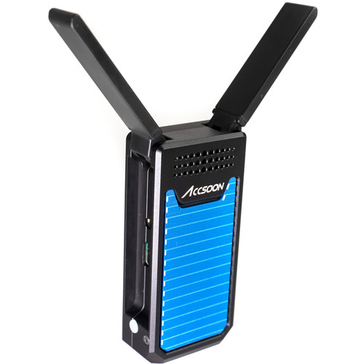

**Source:** <https://static.bhphoto.com/images/images500x500/1578046895_1538166.jpg>

Use Your IOS/Android Devices as Monitors

Transmits up to 1080p Video, HDMI Input

Sends to up to 2 Devices Simultaneously

Up to 328' Transmission over 5 GHz Wi-Fi

$149.00

1. **HOLLYLAND Mars 400S**

1080p60 transmitter/receiver

400' line-of-sight transmission range

have an SDI and HDMI connection

capable of sending the signal over built-in Wi-Fi to up to four mobile devices

have an OLED display

$649.00

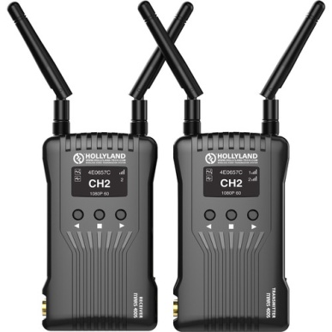

**Source:** <https://static.bhphoto.com/images/images500x500/hollyland_mars_400s_mars_400s_sdi_hdmi_wireless_1590063910_1507628.jpg>

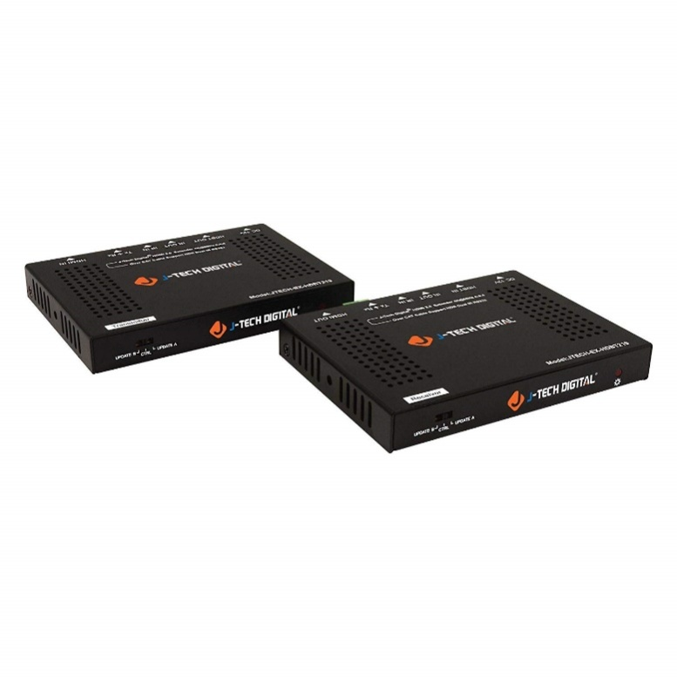

1. **J-Tech Digital HDBT219**

4K@60Hz

1080P up to 230 feet (70 meters)

Supports latest high dynamic range (HDR10@4K60HZ)

$249.95

**Source:** <https://jtechdigital.com/wp-content/uploads/product/jtd-219/jtd-219-1.jpg>

# CONCULSION

The halogen lamps typically used in surgical task lights suffer from relatively low luminous efficacy (lumens of light output per watt of input power), which is only worsened by filters that must be used to reduce the amount of non-visible radiation they emit. LED surgical task lights typically do not require such filtering media, and their higher efficacy can allow for reductions in connected load of 50 percent or more, with potential for additional energy savings through constant-color dimming and reduced cooling load in the operating room. Thus Use of LED Operational Theatre Lights in Operation Room will be better for both patients and the surgeon.

The Surgical Light Camera should meets its requirements like No latency or delay, No compression, Higher frame rate and Longer range should not be as high preference as quality and speed are.

Ultra Wideband (UWB) based wireless video devices can be use in the operating room.UWB is a technology that truly satisfies OR requirements for a medical‐grade wireless video system.

Sony innovative OLED (Organic Light Emitting Diodes) technology which delivers deep black, high-contrast, accurate color reproduction and quick response times with virtually no motion blur can be used for the video data transmission.

After considering various critical factors for wireless video data transmission systems like cost, size, power consumption, latency, etc we found certain good solution's which can be actually introduced in the product and worked upon.

One of the best systems is Accsoon Cineeye Air; it can transmit up to 1080p video having 328 feet transmission line at a frequency of 5GHz, both IOS and Android devices can be used as monitors more over it can be used over 2 devices simultaneously. And the best part is it has a reasonable low price of just $149 hence making it a cost effective solution.

# APPENDIX A: CAMERA SUPPORT FOR OPERATION THEATRE VIDEOGRAPHY

Various methods of digital video recording in the operating theatre include e**ndoscopic cameras** , **head-mounted cameras** , cameras mounted on the surgical light , miniature cameras placed directly in the operative field and specially constructed arms .

# The main elements restricting camera placement in the operating theatre are:

# 1. The surgical team : Surgeons and sterile nurses work close to the operative field, blocking the view from most angles.

# 2. The operating theatre equipment : Both fixed (lamps, ceiling-mounted racks etc.) and mobile equipment in the operating theatre restrict the placement of the camera.

# 3. Anatomical orientation:For viewer, the video image ina surgical video needs to be orientated according to the anatomy. This mean that the cranial direction is screen up and the caudal direction screen down. When deviating from this (e.g. operations in the pelvis) it is preferable to choose surgeon’s viewpoint.

# In order to put the camera up and above the operative field, the support is designed like gallows ’ , with the camera mounted on the distal end of a horizontal boom that extends laterally from the top of a vertical support column ( Figure 36).

# https://www.researchgate.net/profile/Havard_Danielsen/publication/221684153/figure/fig1/AS:552629584568320@1508768568406/3D-model-of-the-camera-support-J-Vis-Commun-Med-Downloaded-from-informahealthcarecom-by_W640.jpg

# Figure 36: 3D model of the camera support

# Source:<https://www.researchgate.net/publication/221684153_A_camera_support_for_operating_theatre_videography>

# The column rests on an electric lifting column, which provides both a low centre of gravity and a motorized height-adjustment of 40 cm. The lifting column rests on a ‘ U ’-shaped base fitted with four anti-static wheels on castors that rotate 360 ° . This makes it easy to move support using four handles placed on the sides of the column and boom. A padded ring is placed around the camera, to protect it from damage and make it easier to place a sterile drape around it when that is required.

# All the electrical wiring is placed inside the support: video and remote cables from the camera and power to the camera and lifting column. The power is turned on/off with a switch on a junction box at the bottom back of support. The lifting column is operated with a foot switch placed on the bottom of the same box.

# All camera parameters (white balance, focus, aperture, pan, and zoom) are controlled between camera and recording unit achieved by placing the remote unit, HDD recorder and 8-inchliquid crystal display (LCD) monitor in portable plastic hard case (Figure 37).

# 

# Figure 37: Video still showing close-up of the operative field.

# Source: <https://www.researchgate.net/publication/221684153_A_camera_support_for_operating_theatre_videography>

# Before making a video recording the hard case unit is connected to the camera support with video and remote cables. The hard case can be set up on a small table in any available space in the operating theatre, out of the way of the surgical team. After use the support can be stored in the surgery ward, while the hard case is brought to the editing suite for transfer of the video material.

**APPENDIX B: ORTHOGONAL FREQUENCY DIVISION MULTIPLEXING**

Abstract Orthogonal frequency division multiplexing (OFDM) is a popular method for high data rate wireless transmission. OFDM may be combined with antenna arrays at the transmitter and receiver to increase the diversity gain and/or to enhance the system capacity on time-variant and frequency-selective channels, resulting in a multiple-input multiple-output (MIMO) configuration. This paper explores various physical layer research challenges in MIMO-OFDM system design, including physical channel measurements and modeling, analog beam forming techniques using adaptive antenna arrays, space–time techniques for MIMO-OFDM, error control coding techniques, OFDM preamble and packet design, and signal processing algorithms used for performing time and frequency synchronization, channel estimation, and channel tracking in MIMO-OFDM systems.

OFDM converts a frequency-selective channel into a parallel collection of frequency flat subchannels. The sub-carriers have the minimum frequency separation required to maintain orthogonality of their corresponding time domain waveforms, yet the signal spectra corresponding to the different subcarriers overlap in frequency. Hence, the available bandwidth is used very efficiently. If knowledge of the channel is available at the transmitter, then the OFDM transmitter can adapt its signaling strategy to match the channel.

**DETERMINISTIC AND RANDOM SIGNALS**

A deterministic signal can be modelled as a completely specified function of time. In other words, there is no uncertainty about its value at any time. For example, the sinusoid signal A cos(2...fct + μ) is deterministic if A, fc and μ are known constants. A random (or stochastic) signal cannot be completely specified as a function of time and must be modelled probabilistically.

**ANALOG AND DIGITAL SIGNALS**

An analog signal is a continuous function of time, for which the amplitude is also continuous. Analog signals arise whenever a physical waveform (e.g., a speech wave) is converted to an electrical signal. A digital signal is a discrete function of time, for which the amplitude can only have a finite set of values. Sometimes a distinction is also made of discrete-time signals—these are signals that are a discrete function of time, but the amplitude may take on a continuum of values.

A very commonly-used random process is white noise. White noise is often used to model the thermal noise in electronic systems. By definition, the random process X(t) is called white noise if SX(f) is constant for all frequencies. By convention, the constant is usually denoted by N02.

The random process X(t) is called a white noise process if

SX(f)=N02, for all f.

Before going any further, let's calculate the expected power in X(t). We have E[X(t)2]=∫∞−∞SX(f)df=∫∞−∞N02df=∞.

Thus, white noise, as defined above, has infinite power! In reality, white noise is in fact an approximation to the noise that is observed in real systems.

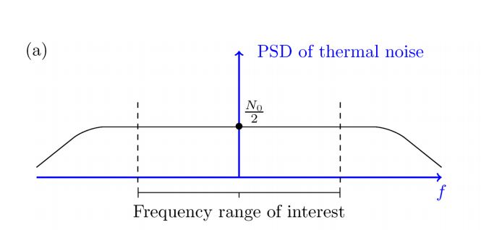

Figure 38: Part (a): PSD of thermal noise;

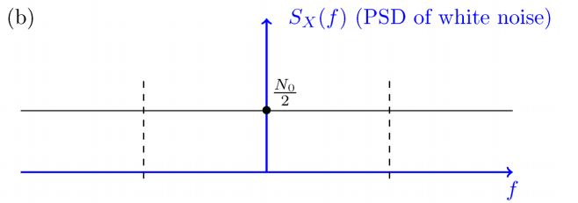

Part (b) PSD of white noise.

Source: <https://www.researchgate.net/publication/342283560_Orthogonal_frequency_division_multiplexing>

Part (a) in the figure shows what the real PSD of a thermal noise might look like. As we see, the PSD is not constant for all frequencies; however, it is approximately constant over the frequency range that we are interested in. In other words, real systems are bandlimited and work on a limited range of frequencies. For the frequency range that we are interested in, the two PSDs (the PSD in Part (a) and the PSD of the white noise, shown in Part (b)) are approximately the same.

The thermal noise in electronic systems is usually modeled as a white Gaussian noise process. It is usually assumed that it has zero mean μX=0 and is Gaussian.

**APPENDIX C: TOWARD 5G CLOUD RADIO ACCESS NETWORK: AN ENERGY ANDLATENCY PERSPECTIVE**

Future generation networks will entirely deploy virtualization paradigms toenhance performance and capabilities of current cellular networks. In order toachieve the vision of fifth-generation networks, software-defined networkingand network function virtualization will be applied not only at the core net-work but also at the radio access network. That will help to achieve significantreduction in power consumption while increasing energy efficiency, flexibil-ity, and scalability. This article proposes a general mathematical model thatcan correctly and accurately describe spatial/topological characteristics, powerconsumption, and latency of Cloud radio access network in future generationnetworks.

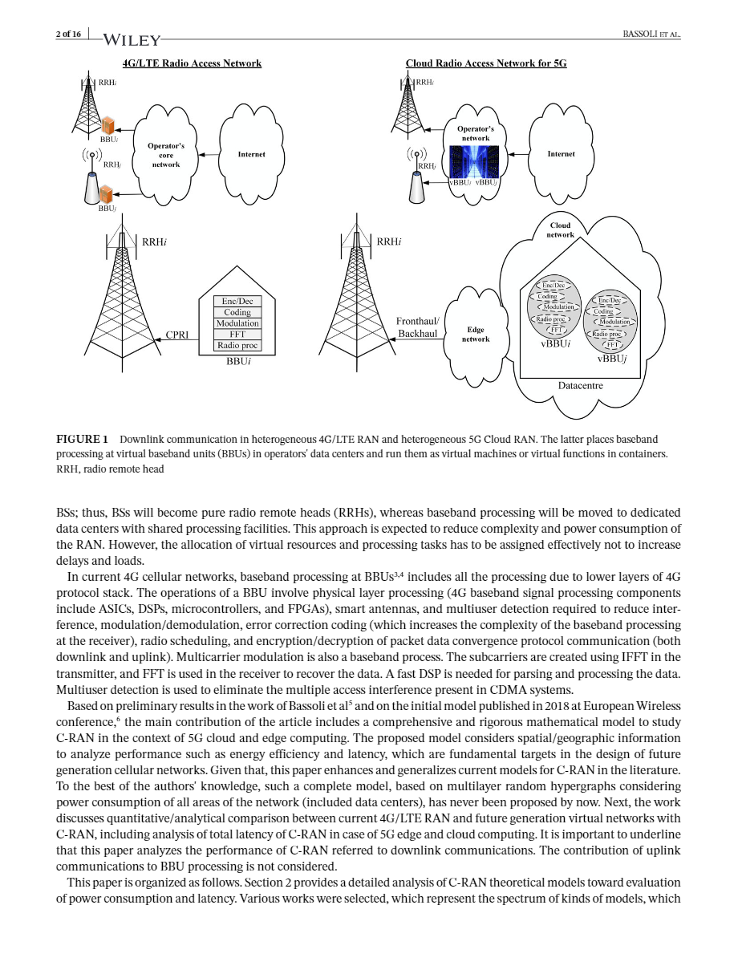

### Figure 39: Downlink communication in heterogeneous 4G/LTE RAN and heterogeneous 5G Cloud RAN.

### Source:<https://www.researchgate.net/publication/333831837_Toward_5G_cloud_radio_access_network_An_energy_and_latency_perspective>

### In current 4G cellular networks, baseband processing at BBUs3,4includes all the processing due to lower layers of 4Gprotocol stack. The operations of a BBU involve physical layer processing (4G baseband signal processing componentsinclude ASICs, DSPs, microcontrollers, and FPGAs), smart antennas, and multiuser detection required to reduce inter-ference, modulation/demodulation, error correction coding (which increases the complexity of the baseband processingat the receiver), radio scheduling, and encryption/decryption of packet data convergence protocol communication . Multicarrier modulation is also a baseband process. The subcarriers are created using IFFT in thetransmitter, and FFT is used in the receiver to recover the data. A fast DSP is needed for parsing and processing the data.Multiuser detection is used to eliminate the multiple access interference present in CDMA systems.

### 5G SYSTEM MODEL

### Graph theory is the area of mathematics that has allowed effective modeling of communication networks as a whole.Wired networks have always been modeled as planar graphs, composed by a set of nodes (eg, switches, routers, etc) and aset of edges (ie, wired links). Side by side, a planar hypergraph is a graph's generalization where edges can connect groupof nodes to each others (ie, not connecting only two nodes as in normal graphs). By the advent of stochastic geometryand random graphs to model wireless cellular networks, hypergraphs have lost their central role in modeling wirelessnetworks. However, while random graphs are useful to model the nature of legacy access cellular networks, the complexityof virtual networks in 5G requires a more complex and flexible architecture.

### 

### FIGURE 40 :Example of structure of a multilayer hypergraph (on the left). The subsets of nodes are represented with different colors

### Source: <https://www.researchgate.net/publication/333831837_Toward_5G_cloud_radio_access_network_An_energy_and_latency_perspective>

### Figure 2 depicts an example of random multilayer hypergraph. This example of hypergraph has two layersL1andL2(a=2), whereL1is composed by a single sublayerΛ11andL2is composed by two sublayersΛ21andΛ22.IfL1representsa single-tier cellular network, its hyperedges can be identified via Voronoi tessellation. In the rest of this paper, since wewill work on multitier networks, the specific tessellation will be a multiplicatively-weighted (MW) Voronoi tessellation.Side by side,L2sublayers are planar graphs, modeling different areas of wired network. The red links, connecting blue andgreen nodes, may model backhaul links.

**REFERENCES**

1. <https://www.lumitex.com/blog/surgical-equipment>
2. <https://www.businesswire.com/news/home/20151115005005/en/NDS-Launches-New-ZeroWire%C2%AE-G2-Advanced-Wireless>
3. <https://www.ndssi.com/medical-monitors-visualization-products/hd-wireless-medical-monitor-devices.html>
4. Ø Ystein H. Horgmo And H Å Vard E. Danielsen “*A Camera Support For Operating Theatre Videography”*, Institute for Medical Informatics, Oslo UniversityHospital,Norway,2012,p20-24  
    Available:

<https://www.researchgate.net/publication/221684153_A_camera_support_for_operating_theatre_videography>

1. <https://vidovation.com/zero-latency-wireless-video/>
2. <https://en.wikipedia.org/wiki/Surgical_lighting>
3. <https://www.steris.com/healthcare/knowledge-center/surgical-equipment/complete-guide-to-surgical-lights>
4. <https://www.superbrightleds.com/blog/led-vs-incandescent-vs-halogen/707/>
5. <https://www.bhphotovideo.com/>

10. Internet Congestion Control by Subir Verma

11. IEEE Explore Organization

12. Wasan Alrawi,” Orthogonal frequency division multiplexing”,University of Technology Iraq,June 2020

Available from:

<https://www.researchgate.net/publication/342283560_Orthogonal_frequency_division_multiplexing>

13. Riccardo Bassoli,Fabrizio GranelliSisay And Tadesse Arzo “*Toward 5G cloud radio access network”,*   Transactions on Emerging Telecommunications Technologies, June 2019

Available from:

<https://www.researchgate.net/publication/333831837_Toward_5G_cloud_radio_access_network_An_energy_and_latency_perspective>

14.<https://insights.regencylighting.com/what-is-correlated-color-temperature-cct-and-how-do-you-choose-it-for-your-lighting>

15. <https://www.indiamart.com/proddetail/led-surgical-head-light-with-camera-and-recorder-from-lumens-medical-20188638573.html>

16. <https://www.blackmagicdesign.com/in/products/miniconverters>. 17.<https://www.tutorialspoint.com/data_communication_computer_network/images/radio_wave_grounded.jpg>

18. https://www.lumitex.com/blog/surgical-equipment

19.<https://insights.regencylighting.com/what-is-correlated-color-temperature-cct-and-how-do-you-choose-it-for-your-lighting>

20. <https://en.wikipedia.org/wiki/Ether_Dome>

21.<https://en.wikipedia.org/wiki/Halogen_lamp>

22.<https://en.wikipedia.org/wiki/Edison_light_bulb>

23.<https://en.wikipedia.org/wiki/Gas-discharge_lamp>

24.<https://en.wikipedia.org/wiki/LED_lamp>

**GLOSSARY**

* **Ad-Hoc Network:**  It is a decentralized type of wireless network which does not rely on pre-existing infrastructure, such as routers in wired networks or access points in managed (infrastructure) wireless networks.
* **Aperture:** an opening, hole, or gap.
* **Auto-Beam steering:** changing the direction of the main lobe of a radiation pattern.
* **Auto-tracking:** Auto-tracking is based on video analysis technology, it is an advanced function that enables camera to automatically detect, follow and record video of moving objects.
* **Benchmarks:** provide a method of comparing the performance of various subsystems across different chip/system architectures.
* **Central Illuminance (Ec):** The Illuminance at 1m distance from the light emitting surface in the light-field center and is measured in lumens per square meter.
* **Colour Rendering Index:** It is a measure of a light source's ability to show object colours realistically or naturally. In other words, to accurately render all frequencies of its colour spectrum when compared to a perfect reference light of a similar type.
* **Correlated Color temperature**: It is essentially a gauge of how yellow or blue the color of light emitted from a light bulb appears. It’s measured in the Kelvin unit and is most commonly found between 2200 Kelvin degrees and 6500 Kelvin degrees.
* **D50:** Diameter of the light field around light field center, ending where the illuminance reaches 50% of central illuminance.
* **Depth of Illumination:** The distance under the light emitting area where the illumination reaches 20% of the central illuminance.
* **Endoscopic Camera:**  An endoscopiccamera is basically little camera along with a long cable which can be used to view tiny areas on a big screen.
* **Fail Safe:**  The backup possibility in case of interruption of the main power supply. The light should be restored in 5 seconds with at least 50 percent of the previous illuminance but not less than 40000luxAnd within 40 seconds the light should be completely restored to original output.
* **Fluorescent:** vividly colourful
* **Head-Mounted Cameras:**  It is an action camera, usually a closed circuit television camera, attached to a helmet allowing someone to make a visual record from their point of view (POV), while keeping their hands and vision free.
* **HDMI:** High**-**DefinitionMultimediaInterface is proprietary audio/video interface  for transmitting uncompressed video data and compressed or uncompressed  digital audio data from an HDMI-compliant source device.
* **HDR:** Highdynamicrangeis a dynamic range higher than what is considered to be standard dynamic range. The term is often used in discussing display devices, photography, 3D rendering, and sound recording including digital imaging and digital audio production.
* **Interruption:** an act, utterance, or period that interrupts someone or something.
* **Lux**: The brightness of a surgical light head is measured in Lux and typically does not exceed 160,000 Lux
* **Light Field Centre:** The point in the light field (lighted area) where illuminance reaches maximum lux. It is the reference point for most measurements.
* **Light Field Diameter d10:** Diameter of the light field around light field center, ending where the illuminance reaches 10% of central illuminance.
* **Ob-Van:** Outside broadcasting is the electronic field production of television or radio programmes from a mobile remote broadcast television studio.
* **Retractor:** a device for retracting something.
* **SDI:** Serial Digital Interface (**SDI**) is a standard for digital video transmission over coaxial cable.
* **Self-healing connection:** technology capable of analysing and repairing itself when problems arise.
* **Surgical Retractor:** It help **surgeons** and operating room professionals hold an incision or wound open during **surgical** procedures. They aid in holding back underlying organs or tissues, allowing doctors/nurses better visibility and access to the exposed area.
* **White Balance:** White balance (WB) is the process of removing unrealistic color casts, so that objects which appear white in person are rendered white in your photo. Proper camera white balance has to take into account "color temperature" of a light source.